**Homework on literature search & reference management**

**1. Please list the topic(s) that you are interested in for this assignment.**

AI Chip, Cloud computing

**2. Firstly, search literatures on the topic that you are interested in (e.g., “AI Chips”, etc.) and analyze the records searched through** [Web of Science](http://202.120.57.240/f/database/database_detail.shtml?id=55&lang=en-us)**,** [IEEE Xplore](https://ieeexplore.ieee.org/Xplore/home.jsp) or [ACM Digital Library](https://dl.acm.org/), **and answer the following questions:**

1) Describe the publication year distribution of the searched records (you can also answer by screenshots).

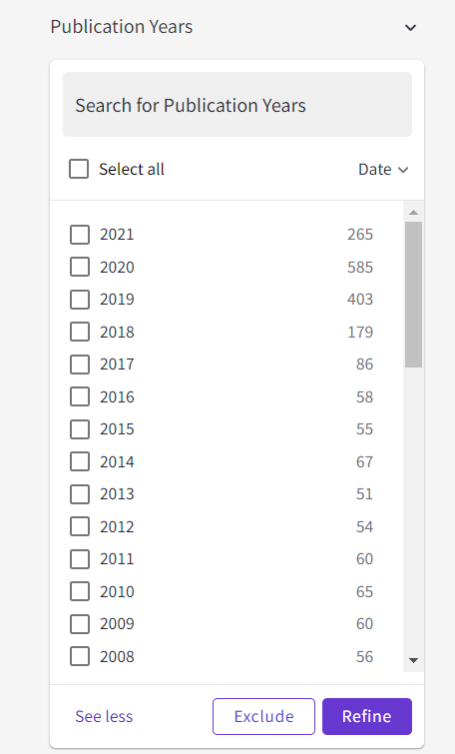

2) Who writes the most articles? (Please write the author name and the numerial number of articles he or she wrote, and paste related screen capture.)

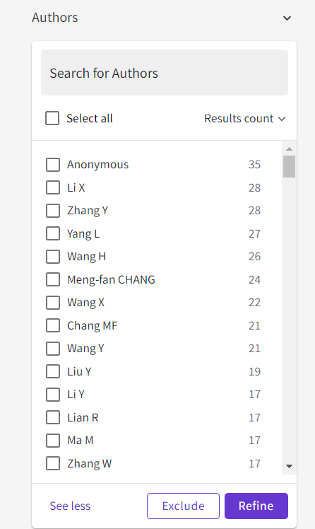

3) Whose articles are the most concerned? (You could choose by highly cited papers, frequently-used articles, etc. Please write the related information and paste the screen capture. )

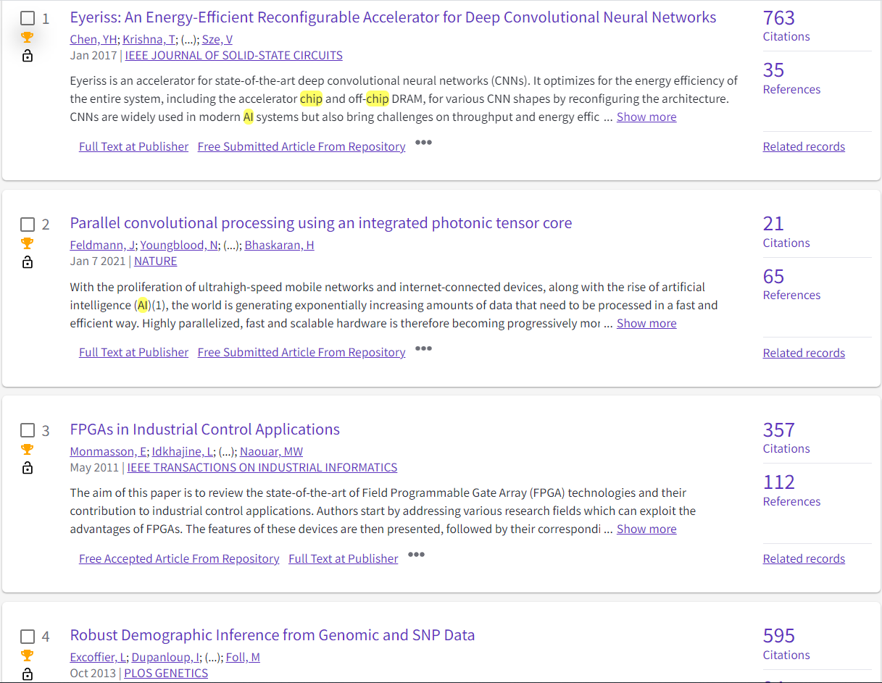

4) Which paper(s) did you choose for your presentation and why?

Eyeriss: An Energy-Efficient Reconfigurable Accelerator for Deep Convolutional Neural Networks

I choose this because it is the most highly cited among the searched results of web of science. Besides, it is published in 2017, not too early. Moreover, it is quite related to the topic I want to discover, because it discusses about the ai chips, accelerator and computer architecture with energy-efficient design.

**Notes:**

1. Use key words in the literature search, e.g., “cloud computing”. Besides, try to use different forms, representative synonyms and near-synonyms of the key words, e.g., different forms and synonyms of “electric vehicle*” can be “electric car*”, EV, etc.

2. When you want to access the databases off campus, you could try the VPN Service or Proxy Service: <http://net.sjtu.edu.cn/wlfw/xywdl.htm>.

(Created by Ms. Qinling Huang, mechanical engineering librarian of SJTU)